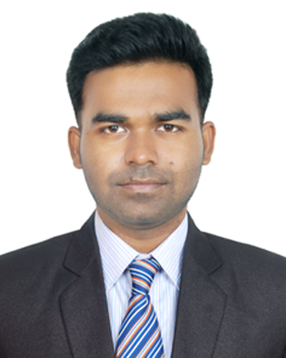Résumé of

**Shahriar Kabir Emon**

**Mailing Address:**

81 Sukrabad, Dhanmondy, Dhaka-1207

C:\Users\Shahriar Emon\Downloads\LinkedIn-Logo-1024x289.png **Shahriar Kabir Emon**

**C:\Users\Shahriar Emon\Downloads\logo_twitter.png** **@kabir\_emon**

C:\Users\Shahriar Emon\Downloads\cv_59_8762197036636605422.png **em**

* **[on.shariar@yahoo.com](mailto:on.shariar@yahoo.com)**

**C:\Users\Shahriar Emon\Downloads\gmail-logo-1920.png** [**emon.shariar.es@gamil.com**](mailto:emon.shariar.es@gamil.com)

C:\Users\Shahriar Emon\Downloads\mobile-phone-logo-icon-92641.png **01717613422**

**Career Objective**

Willing to build up career in a challenging position myself as a quick learner and highly energetic person to face any challenge in Business, Customer Service or Marketing sector.

**Self Belief**

I believe in 3 P’s - Patience, Persistence and Positivity. I believe this unbeatable combination will help me to achieve my goal. Moreover, I have strong analytical & interpersonal skills with an ability to work under pressure.

**Educational Qualification**

**Bachelor of Business Administration : Major in Marketing**

Institution : Daffodil International University

Result : CGPA 2.87 out of 4.00

**Higher Secondary Certificate (H.S.C) : Business studies**

Institution : Keshabpur Degree College

Board : Jessore Board

Result : CGPA 3.88 out of 5.00

Year of Passing : 2012

**Secondary School Certificate (S.S.C) : Science**

Institution : Keshabpur Pilot School And College

Board : Jessore Board

Result : CGPA **4.50** out of 5.00

Year of Passing : 2010

**Training Course, Workshop and Seminar Participation**

|  |  |  |
| --- | --- | --- |
| **Title** | **Objectives** | **Durations** |
| 1.Seminar on Grooming for Future, Let’s Brand Yourself” Organized by Department of Business Administration | Developing personal skill & brand yourself | 18th February,2017 |
| 2.Business Case Competition Organized by Business & Education Club | Developing strategy for an organization | 30th November,2016 |
| 3.Seminer on DIU Industry Academia Lecture1 Delivered by AL-haj Sufi Mohammed Mizanur Rahman, Chairman, PHP Family | Struggling for innovation and achieving success | 30 March 2016 |
| 4.Seminar on DIU Industry Academia Lecture 2 Delivered by Mr. Syed Manzur Elahi, Chairman, Apex Group | Motivating the educated the youths of the struggle and challenges faced on route to success | 11 June 2016 |
| 5.Day-Long Training Session on Mastering On Presentation | Developing presentation skills | 29th February,2012 |
| 6.National Computer Training Institute | For developing basic idea about MS Word, excel, power point | 01/05-01/08,2011 |

**Strengths:**

* Punctual and **hardworking**, able to work under pressure.
* **Self confidence**, able to convince populace
* A strong drive for responsibility and task completion
* Able to work in a group under the guidance of others, and have the **ability to guide others**

**Skills and abilities:**

* Worked as a volunteer at CDC
* Was an active member of Social Services Club
* Proficient in speaking, reading, writing and listening in English.

**Experience:** Marketing Executive (Transcom Group)\*

**Computer Skill**

* Operating System: Windows 7/8/10,Xp
* Office Management: MS-Word, MS-Excel, PowerPoint, Deep Internet Browsing .

**Personal Information**

Name : Shahriar Kabir Emon

Sex : Male

Father’s name : M.A Khaleque

Mother’s Name : Shakila Yesmin

Date of Birth : 14/12/1993

Nationality : Bangladeshi (by birth)

Religion : Islam

Height : 5.7’’

Blood Group : B+

National ID : 19934123801000002

**Permanent Address** :Trisha Plaza, Main road, Keshabpur, Jessore

**Vill + P.O**  : Keshabpur

**Police Station**  : Keshabpur

**District**  : Jessore

**References**

|  |  |
| --- | --- |
| Name : Mr.Syed Maruf Reza  Associate Professor and Head  Department of Entrepreneurship  4/2, Sobhanbag, DT# 05  Dhanmondi, Dhaka-1207.  Contact No:+8801712142995  E-Mail:**marufreza@daffodilvarsity.edu.bd** | Sahed Kamal (Engineer)  Procurement Manager  Bangladesh Medicle College, Dhaka  Mob: 01711544574 |

**I do hereby declare that above information about me are correct.**

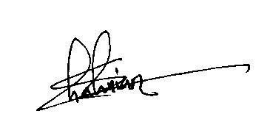

**Signature: \_ \_ \_ \_ \_ \_ \_ \_**

**Shahriar Kabir Emon**